**A Data-Agricultural Crop Production India Analayis (1997-2021)**

**1.INTRODUCTION**

**1.1Overview**

**Agriculture is an evolutionary process that consists of a series of activities such as the production of food, fibers, feed, and raising of domesticated animals to fulfill the demand of the population. Agriculture is a key to development in the area of human civilization.In India, the main objectives of agricultural policy are to remove the major problems of agricultural sector related to improper and inefficient uses of natural resources, predominance of low-value agriculture, poor cost-benefit ratio of the sectoral activities and insignificant progress of co­operative farming and other self-help institutions.**

**Crop production is a common agricultural practice followed by worldwide farmers to grow and produce crops to use as food and fibre. This practice includes all the feed sources that are required to maintain and produce crops. Listed below are few practices used during crop production. Preparation of Soil.**

**Crop productivity is the quantitative measure of crop yield in given measured area of field. The use of new crop varieties and the efficient application of agrochemicals, immensely contributed to increased plant productivity Agriculture is the practice of cultivating plants and livestock in order to provide facilities the human beings. In the rise of the sedentary human lifestyle agriculture was the key development.**

**1.2 Purpose**

**Agriculture is the foundation of the Indian economy. The population of India mostly depends on agriculture for their livelihood and agriculture contributes to 40 percent of the total GDP of the country.Agriculture impacts society in many ways, including: supporting livelihoods through food, habitat, and jobs; providing raw materials for food and other products; and building strong economies through trade.**

**2.Problem Defination And Design Thinking**

**2.1 Empathy map**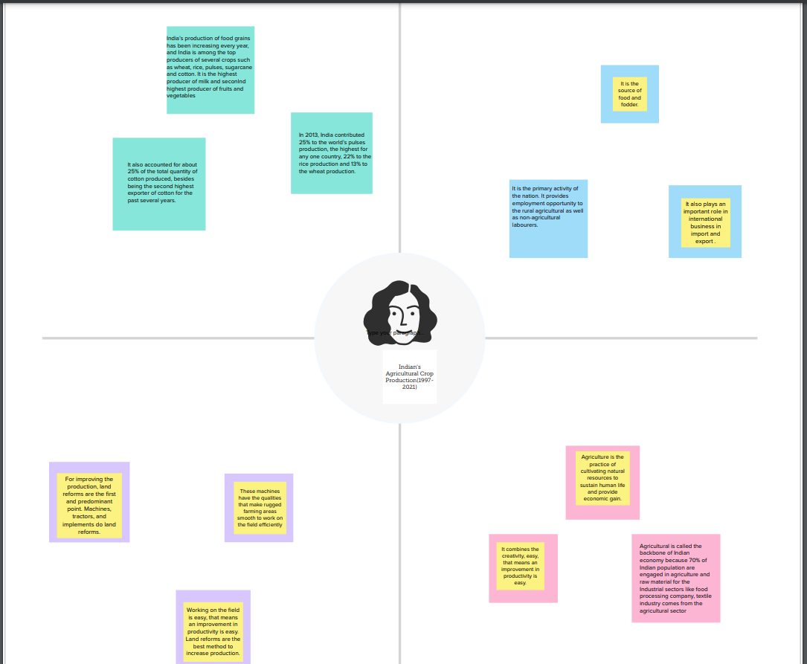

**2.2 Ideation And Brainstorming Map**

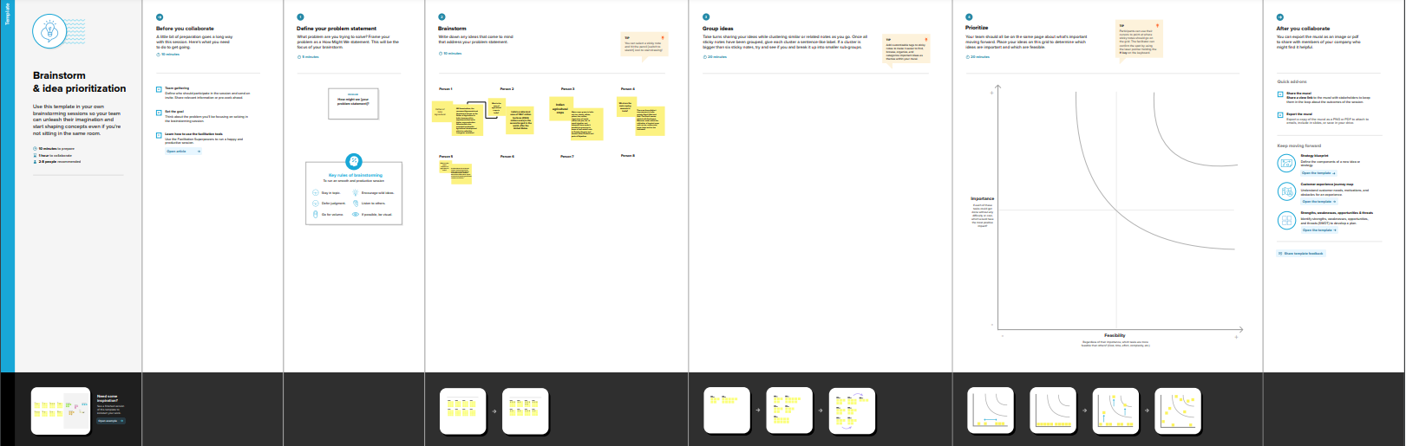

**Result**

**Dash Board**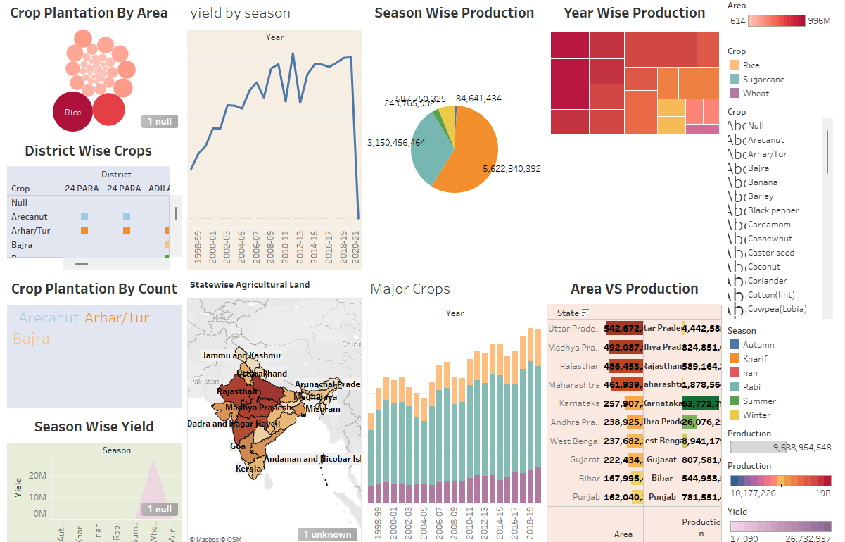

**Story**



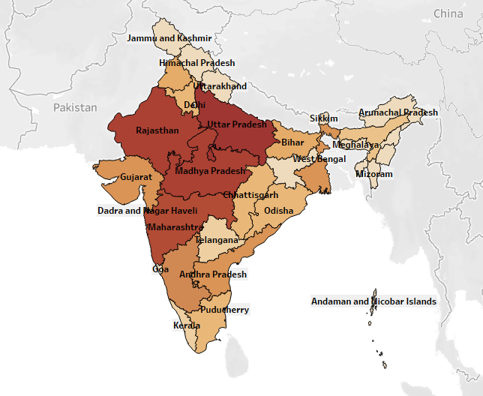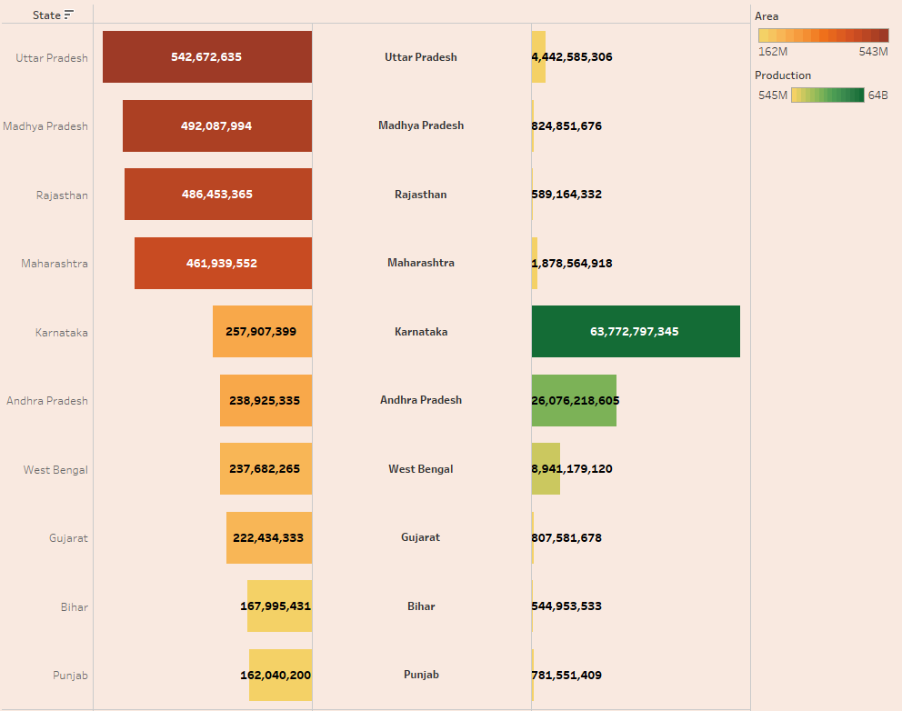

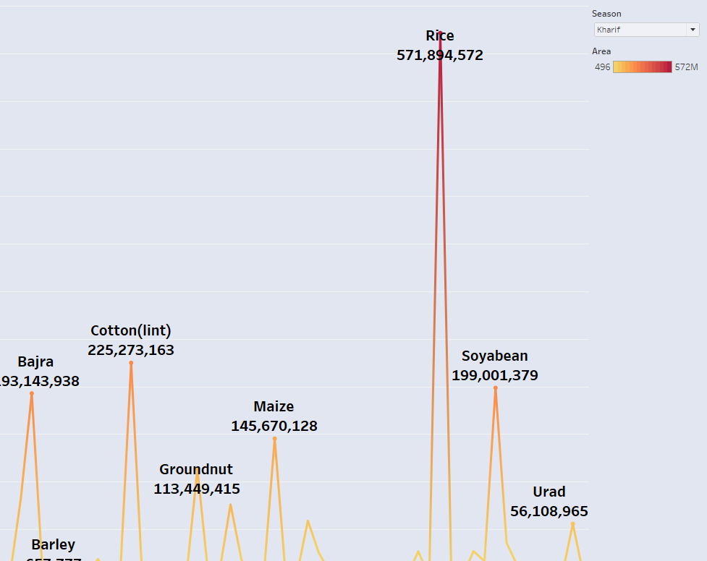

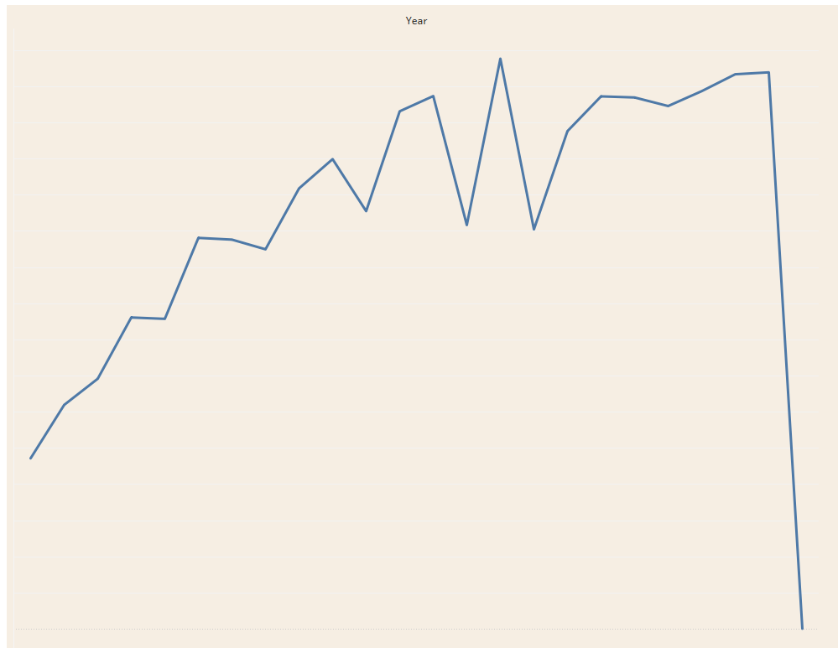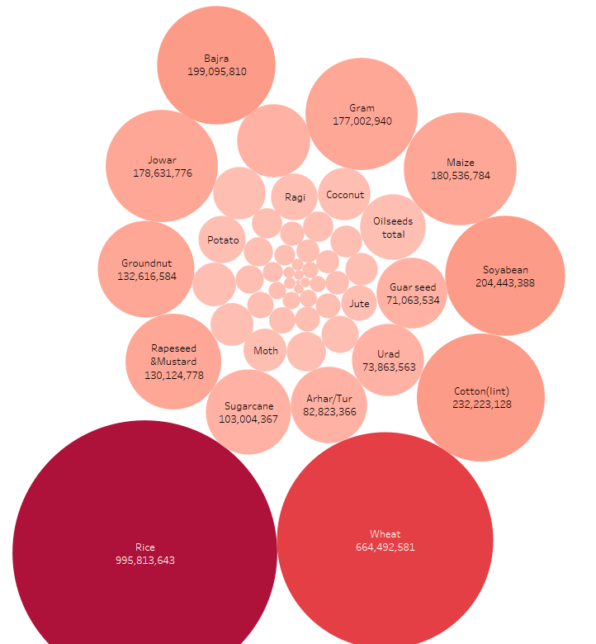

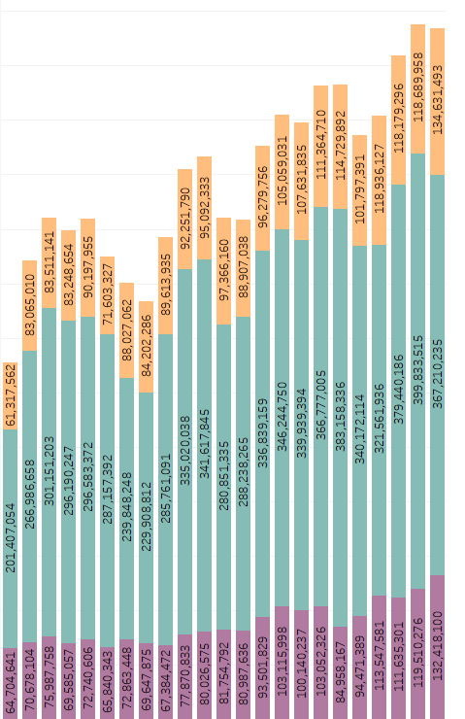

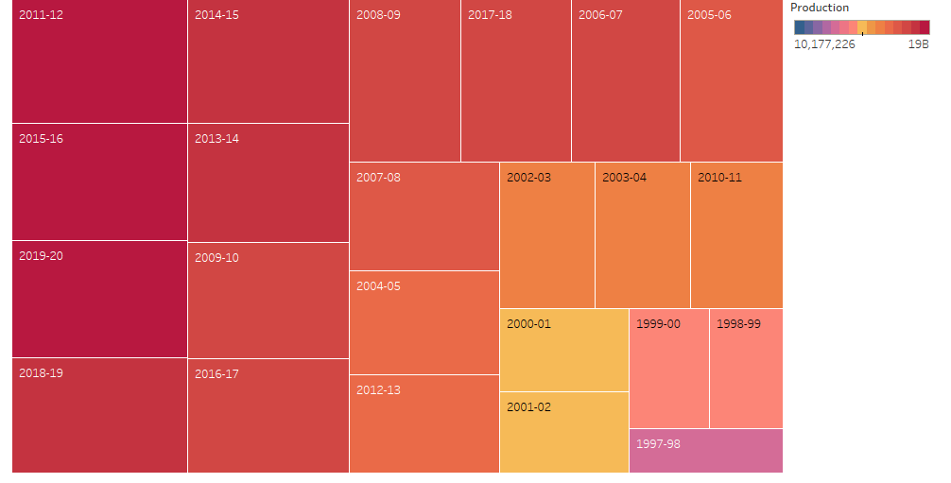

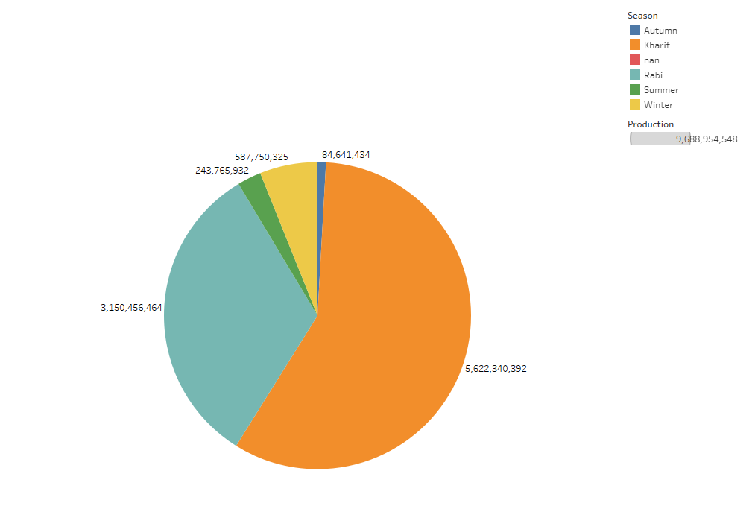

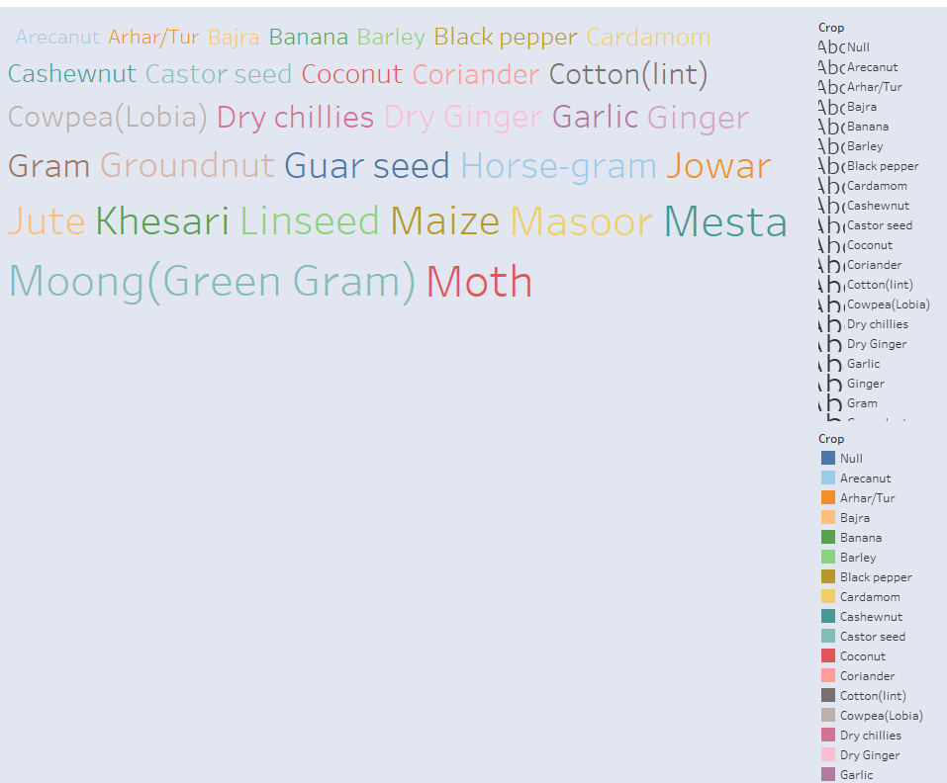

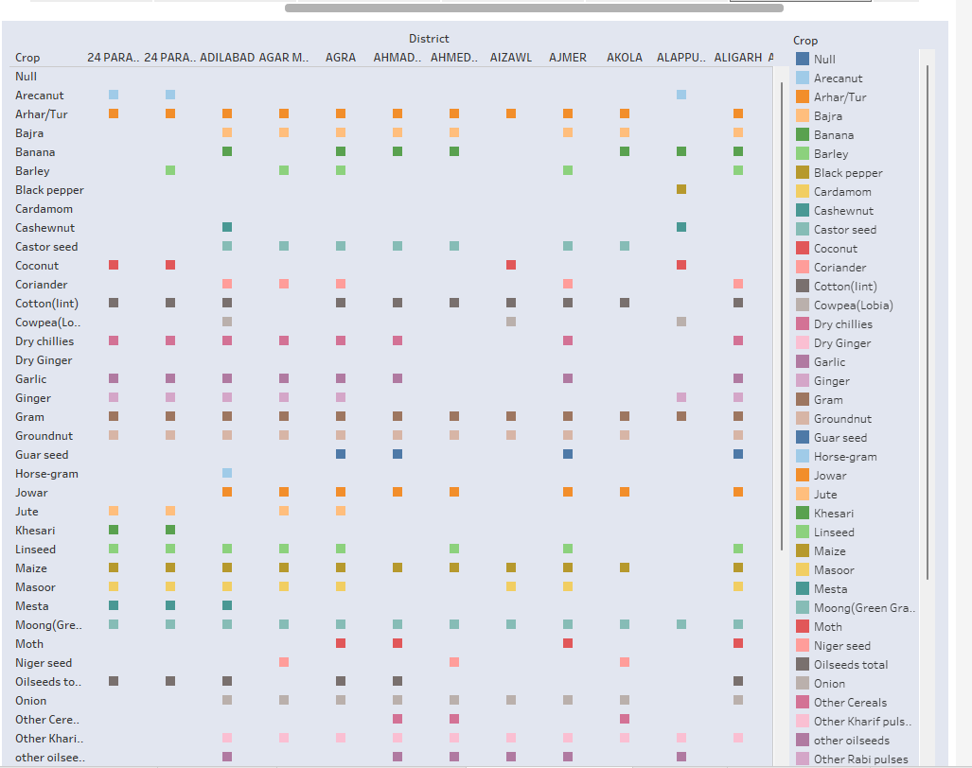

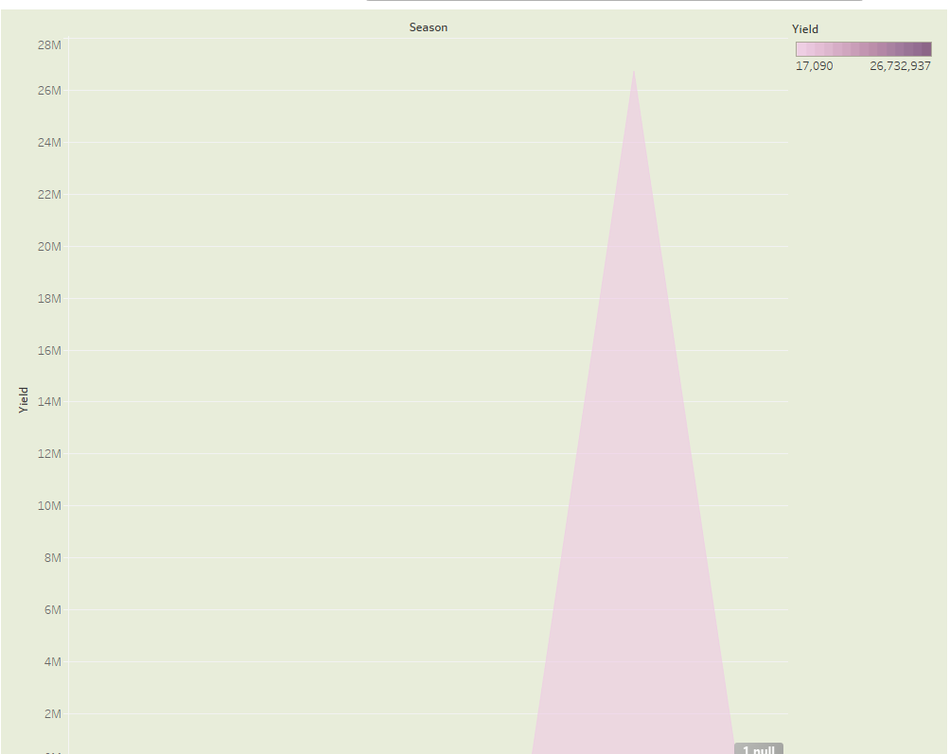

**Advantage**

1.If the main crop is damaged, the inter crop will be the life saviour of the farmer.

2.The land exposed will be less, if an intercrop is added, there by reducing the weed growth.

3.The run off can be reduced.

4.Soil erosion can be decreased

**Disadvantage**

1. Yield decreases as the crops differ in their competitive abilities.

2. Management of I/c having different cultural practices seems to be difficult task.

3. Improved implements cannot be used efficiently.

4. Higher amount of fertilizer or irrigation water cannot be utilized properly as the component crops vary in their response of these resources.

5. Harvesting is difficult.

**Application**

Agriculture technology or Agri technology is also known as agritech. It is efficient in mapping, monitoring, and managing farming decisions precisely. Agriculture solutions come in various formats such as satellite imagery, sensors, agriculture machines, and software solutions It plays a vital role in the economic growth of the country by contributing to around 14 to 15 % of the Gross Domestic Product (GDP).

**Conclusion**

Traditional agriculture is an extractable process where all resources - human, water, and land - are taken and applied to immediate use. Modern agriculture uses planned technology and emphasizes management practices of conservation and renewability of resources.

 It plays a vital role in the economic growth of the country by contributing to around 14 to 15 % of the Gross Domestic Product (GDP).

**Future Scope**

Yes, agriculture is good for the future as it is expected to use advanced technologies and innovations to produce more food with limited land and resources, increase efficiency on farms, and become more profitable, efficient, safe, and environment friendly.

It denotes that the greater the advanced stage of development of agricultural nations, the greater the contribution of agriculture to national earnings**.**